Press RELEASE
(VR/IM)

The new drying device for washing reusables

(Meckenbeuren / Germany, September 2023) –
Winterhalter has developed the new DMX drying device for establishments that have the highest demands for quick and perfect drying results for plastic reusables. Reusables are dried so perfectly in a very short time that they can be stacked and stowed away immediately, without having to let them air dry after washing. Three different device variants are available, depending on the room situation and spatial conditions.

More and more foodservice establishments are opting to use sustainable reusables such as mugs, bowls, menu plates, burger boxes and ice cream cups. Legal regulations to reduce disposable packaging or minimising glass breakage and the associated risk of injury are just two of the reasons for this.

Winterhalter relied on a system solution right from the start in order to achieve the best possible drying for washed reusables: the effective interaction of warewasher, rack and chemicals specially developed for plastic. The warewashing system for reusables has been expanded to include a fourth component to be able to meet the highest demands: the DMX drying device. This turns “very good” drying results into “perfect” drying results. That’s because the residual moisture is so low that it corresponds to complete drying in practice. So, if fast food restaurants, snack bars, clubs, amusement parks, beach bars, swimming pools or event foodservice establishments use a lot of plastic tableware, one rack after the other goes into the warewasher and there is no time or space to air dry afterwards, Winterhalter recommends using the new DMX drying device. The entire film of water is removed after just two minutes, and the reusables can be stacked and stowed away immediately.

The DMX drying device from Winterhalter was developed for washing reusables in the passthrough dishwashers of the PT Series and the undercounter warewashers of the UC Series. Three different device variants are available, depending on the room situation and spatial conditions: passthrough, corner installation and front loading. The drying device has upper and lower drying units. In the upper unit, a circulating air blower directs the air from above onto the wash items to dry the outside of the reusables. In the lower drying unit, fresh air is fed into air distribution pipes with the help of a pressure blower. From there, the air flows from below into the wash items, ensuring that hollow items such as mugs and bowls also dry perfectly on the inside. Depending on the volume of items to be washed and how much time is available, wash items can be dried either with hot air in just two minutes or in the energy-saving ECO programme with air at room temperature.
More information at: www.winterhalter.com/products/drying-device-dmx
(2.736 characters incl. spaces)

Image attachments (all Winterhalter Gastronom GmbH):
Download images:
https://media.winterhalter.com/mc/portal/selection/link?7&guid=18ceda9c6538e605

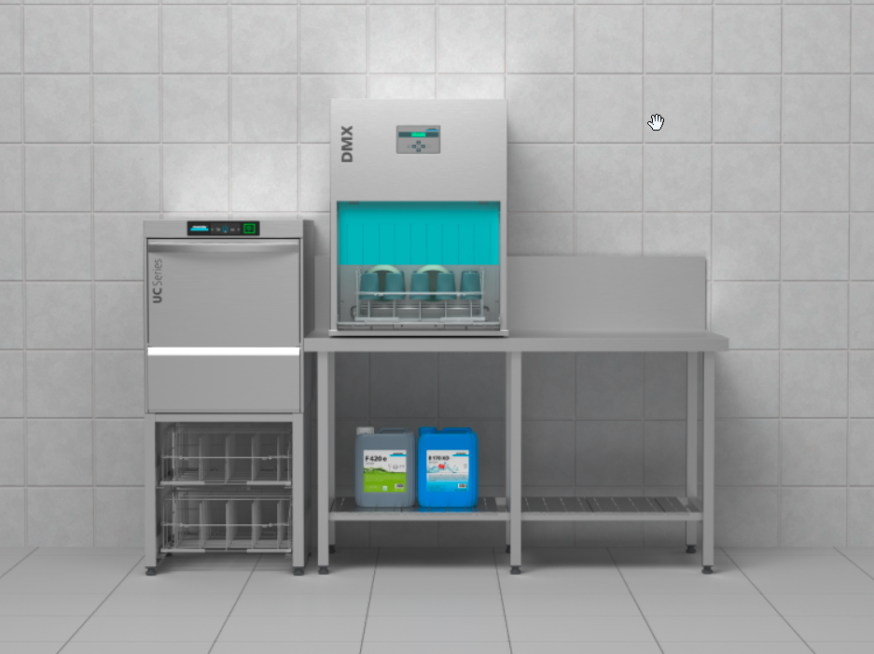
Image 1: Free standing in combination with a UC or PT Series warewasher

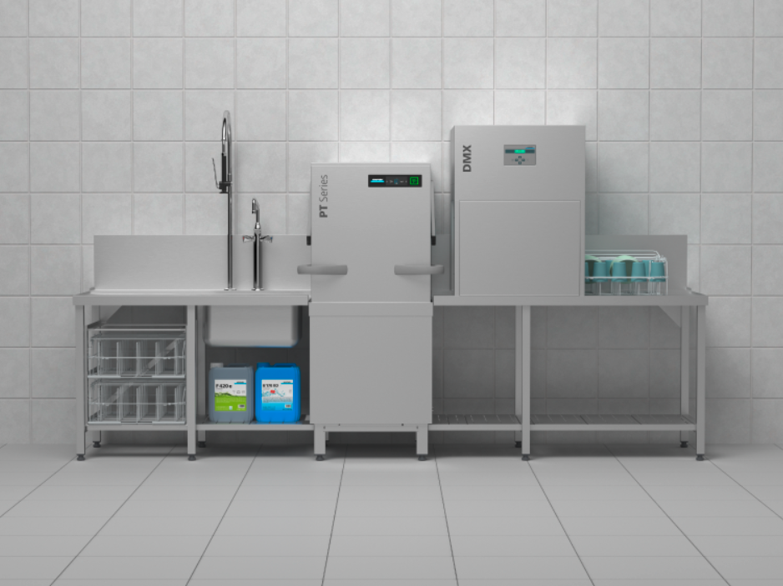
Image 2: Table mounting in combination with a PT Series passthrough dishwasher

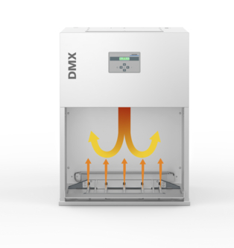

Image 3: Technology and mode of operation

For editors:
Winterhalter Gastronom GmbH was founded in 1947 by Karl Winterhalter in Friedrichshafen on the shore of Lake Constance. Today Jürgen and Ralph Winterhalter, the son and grandson of the founder, run the family company. With more than 2,000 employees worldwide, the owner-operated group is a global player in the commercial kitchen industry.
Winterhalter is a specialist in commercial warewashing systems. With its warewashers, chemicals, water treatment devices and wash racks, Winterhalter offers a comprehensive system that guarantees perfect wash results. In addition, Winterhalter products are characterised by the highest cost-effectiveness and user-friendliness and have been a byword for innovation and reliability in the kitchen for decades.
All over the world, clients from the foodservice sector, chain restaurants, hotels and canteen catering, from bakeries and butcher’s shops rely on the high quality of Winterhalter warewashing products.
The company has its headquarters in Meckenbeuren near Lake Constance. Additional manufacturing locations have been opened in Endingen (Germany) and Rüthi (Switzerland), and in Rayong (Thailand) for the Asian market. Winterhalter is represented worldwide in more than 70 countries by 41 branches or partners.

Further information:
Winterhalter Gastronom GmbH
Verena Rist
Corporate Communication
Winterhalterstrasse 2-12
88074 Meckenbeuren
Telephone: +49 7542 - 402- 5359
Email: verena.rist@winterhalter.de
Website: www.winterhalter.com

